
SCHOOL OF ARCHITECTURE, COMPUTING & ENGINEERING
INDIVIDUAL CW REPORT
Student Name: Soham Nareshbhai Patel
Student Number: U2799710
Module Leader: Dr Umaima Haider
Lab Tutor: Ragul Gowtham Panneer Selvam
Module Code: CN7026 – Cloud Computing
Term: 2024/25 Term 2

Vertical Sector - Smart Campus

Table of Contents

1. | Introduction ..................................................................................................... 3
2. | Project Plan .................................................................................................... 4
3. | Requirements ................................................................................................. 5
3.1. Functional Requirements ............................................................................ 5
3.2. Non-Functional Requirements .................................................................... 5
4. | Data Center and Compliance Standards ...................................................... 6
5. | Cloud Architecture Solution ........................................................................... 7
5.1. Architecture Details .................................................................................... 7
6. | Implementation ............................................................................................... 9
7. | Costing .......................................................................................................... 13
8. | Analysis and Reflection ................................................................................. 14
9. | References .................................................................................................... 15

Introduction
Contemporary learning institutions are gradually transforming into smart learning institutions under the application of IoT, AI, and data analytics. However, there is a crucial problem that tends to emerge, namely data decentralization across different departments. The use of traditional on-premises arrangements causes the development of ‘silo effects,’ inefficient use of resources, slow or even non-existent decision-making and inefficient tracking of students’ attendance or participation. Cloud computing may connect these disparate systems and provide a unique data processing centre with the capabilities of real-time analysis. Through a Smart Campus Hub on the cloud, resources can be managed prudently, and students’ experiences can be forecasted impeccably. This approach makes it possible to interconnect all the data and provide relevant data to the administrators to help in decision-making while boosting sustainability in campus and enhancing the implementation of digital learning.

Project Plan

The project plan is drafted below –

Week | Task | Milestone
Week 1-2 | Requirement analysis, stakeholder consultation, and defining key objectives | Project scope finalised
Week 3-4 | Infrastructure assessment, identifying existing campus systems, and selecting cloud service providers | Cloud platform selection completed
Week 5-6 | Designing cloud-based Smart Campus Hub architecture, ensuring scalability and integration | System architecture blueprint ready
Week 7-8 | Developing data integration pipelines for real-time analytics and cross-departmental access | Data integration framework implemented
Week 9-10 | Implementing security measures, access control, and compliance standards | Security protocols established
Week 11-12 | Testing system functionality, performance evaluation, and user feedback collection | System validation completed
Week 13-14 | Training staff, onboarding students, and deploying smart applications | Full system deployment
Week 15 | Monitoring, troubleshooting, and optimizing for efficiency | Project completion and review
Table 1: Plan

Requirements

3.1 Functional
- AI-powered analytics – Real-time data processing for decision-making
- Centralized Data Management – Unified storage and retrieval across departments
- Automated Resource Allocation – Smart scheduling for classrooms and utilities
- IoT Integration – Sensor-based monitoring for security and energy efficiency
- Cloud-based learning Management – Seamless access to digital educational resources
- Smart Attendance System – Facial recognition or RFID-based tracking
- Predictive Maintenance – AI-driven alerts for equipment and infrastructure upkeep
- Mobile and Web Access – Unified platform for students, faculty, and administrators
- Incident Detection System – Automated alerts for emergencies and security threats
- Dynamic Access Control – Role-based authentication and permissions management

3.2 Non-Functional
- Scalability – The system must efficiently handle increasing numbers of users, data, and devices without performance degradation.
- Low Latency – Real-time response for critical applications like security alerts and AI analytics.
- Regulatory Compliance – Adherence to data protection laws such as GDPR and FERPA for student data privacy.
- User-Friendly Interface – Intuitive dashboards and seamless navigation for students, faculty, and administrators.

Data centre
London is appropriate for smart campus cloud infrastructure due to the availability of an advanced digital environment, stringent laws protecting data, and various educational centres nearby. In this regard, hosting the data centre in London is useful to support the privacy obligations of GDPR regarding student and faculty data. Furthermore, it needs to be compliant with ISO/IEC 27001, an information security management system —international standard, in terms of security.
On the question of cloud service availability, it is better to choose the level of compliance with Uptime Institute Tier III or give preference to the fourth level. The Cyber Essentials certification enhances cybersecurity measures against risks such as cyber threats, while SOC 2 (Service Organisation Control 2) compliance ensures the security and privacy of the data (Wang et al., 2024). Furthermore, adherence to BS 10012 supports personal data governance, crucial for academic environments. Thus, the smart campus cloud infrastructure in London can be prepared to offer a secure, elastic, and compliant environment for educational institutions.

Cloud Architecture Solution
AWS offers the best cloud solution for a smart campus because of the possibilities it presents such as Artificial Intelligence, scalability, and improvement in the available digital learning. These are services such as AWS Lambda, and Amazon Sage Maker which support real time analysis of data assisting institutions to determine resource availability and schedule time for maintenance while at the same time improving security.
To make learning materials more easily accessible, equipped, and distributed, it assigns Amazon Simple Storage Service (S3) to store learning resources or any teaching content and the AWS CloudFront for fast delivery, irrespective of the location of the learning platform, to the student community around the globe. AWS IAM enhances the ability of safe management of access to users and allows access to be role-based for extended course customization per the rules of academic data (Armenatzoglou et al., 2022). In the same regard, it is integrated into smart attendance and security systems as it leverages artificial intelligence facial recognition. This way, with the help of AWS, the appliances that are part of the IoT, automation of some offices’ work and a data-oriented approach in education can be implemented in the smart campus, which led to the growth of the efficiency in all the spheres and students’ interest.

5.1 Architecture
AWS Components for Smart Campus Implementation
- AWS IoT Core – Enables seamless integration of smart devices for campus automation.
- Amazon RDS (Relational Database Service) –This provides efficient management of structured academic and administration data.
- AWS AppSync – Provides real-time data synchronization for campus applications.
- Amazon Kinesis – A Real-Time Stream processing technology which is used to process data gathered from security cameras or IoT devices.
- AWS WAF (Web Application Firewall) – Prevent the threats and attempts to attack the smart campus platform.
- Automatic Workflows – Programs to automate generalized administrative ORDERS such as enrolling students and production of their grades.
- Amazon Comprehend – Enables use NLP in analysing the feedback given by the students and hence improving the decisions that are made in academics.

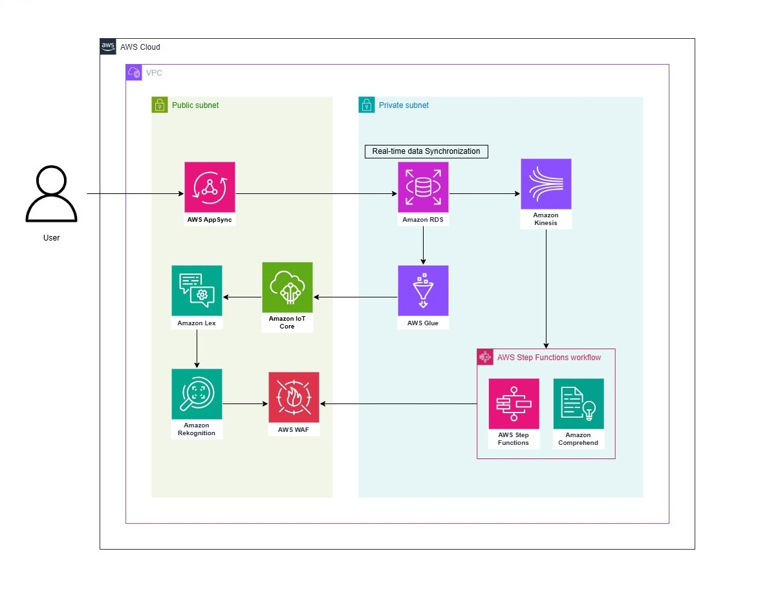Figure 5.1: AWS architecture

Implementation

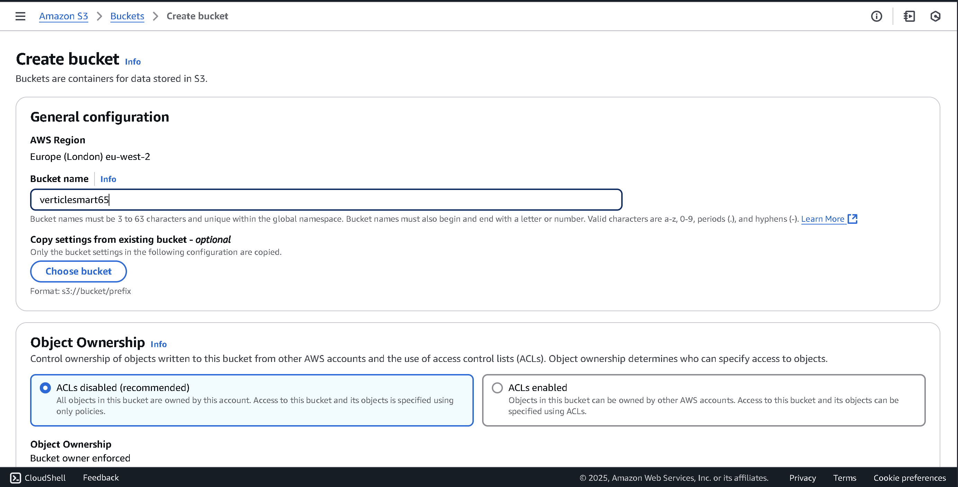Figure 6.1: S3 bucket creating.
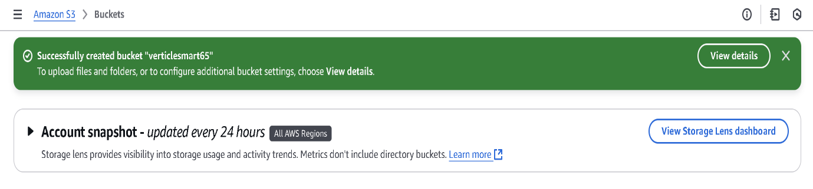Figure 6.2: S3 bucket creation

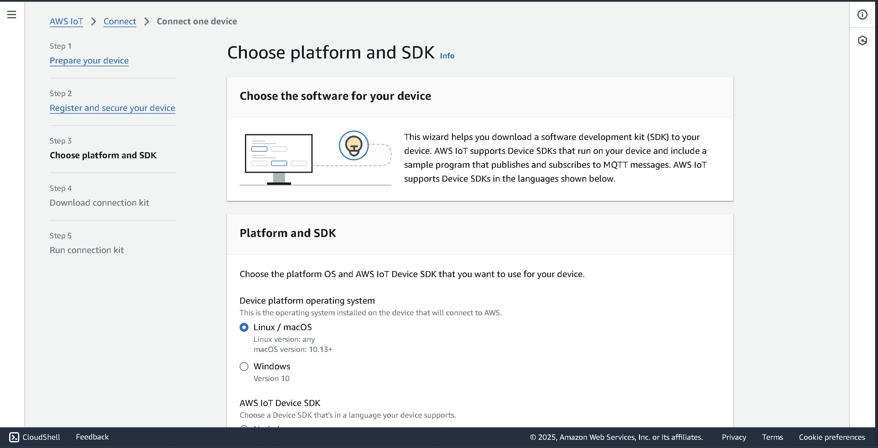Figure 6.3: IoT core device setup details

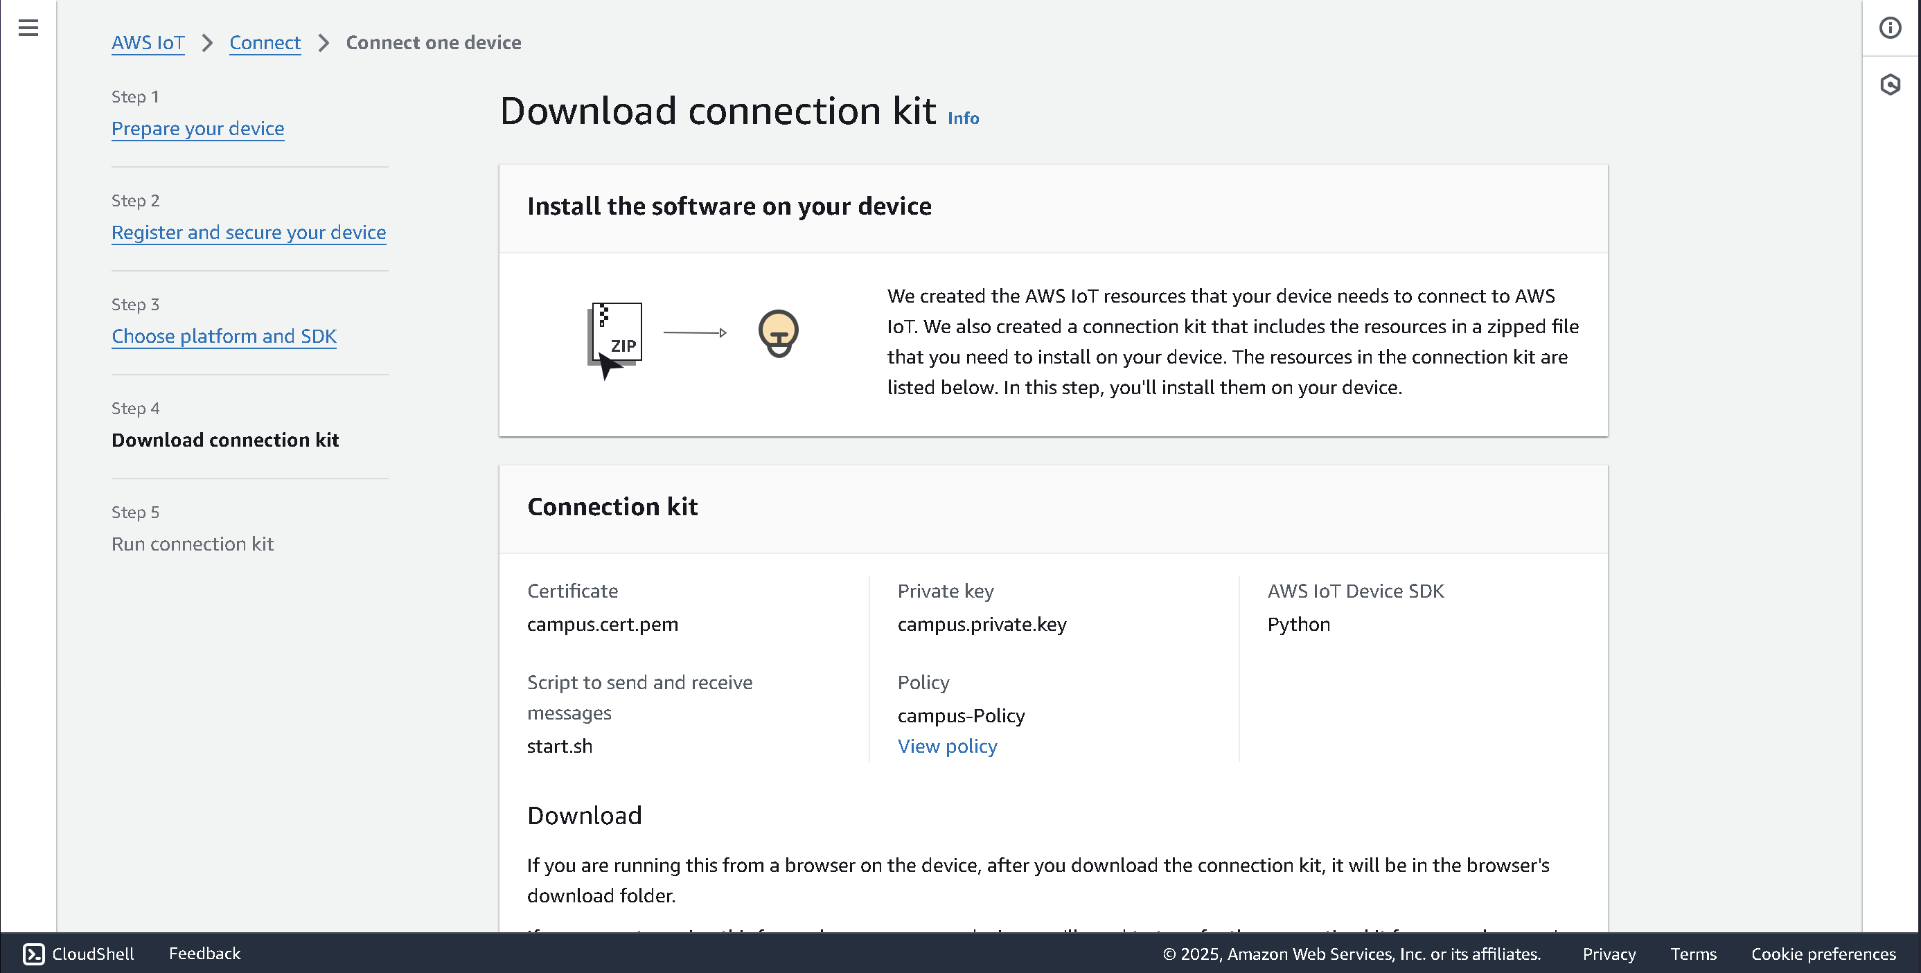Figure 6.4: IoT core device setup

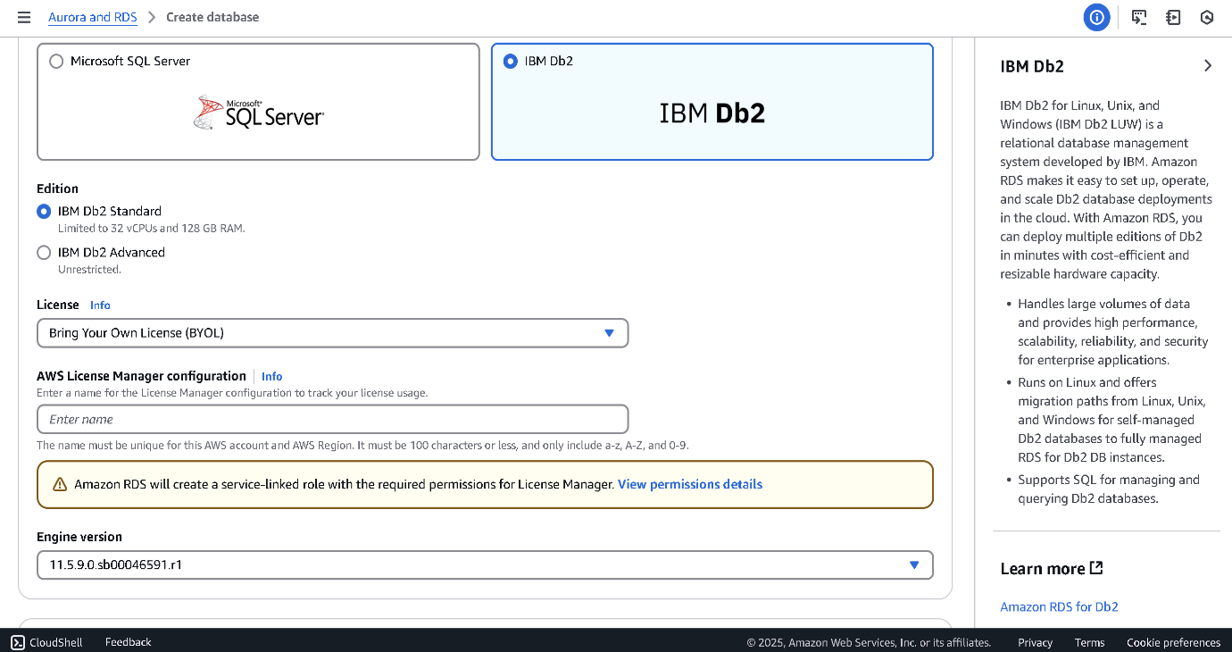Figure 6.5: Implemented RDS for DB2

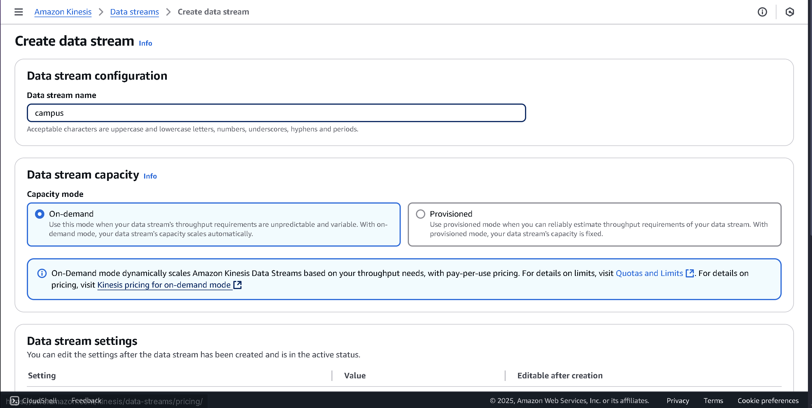Figure 6.6: Created Kinesis Data streams.

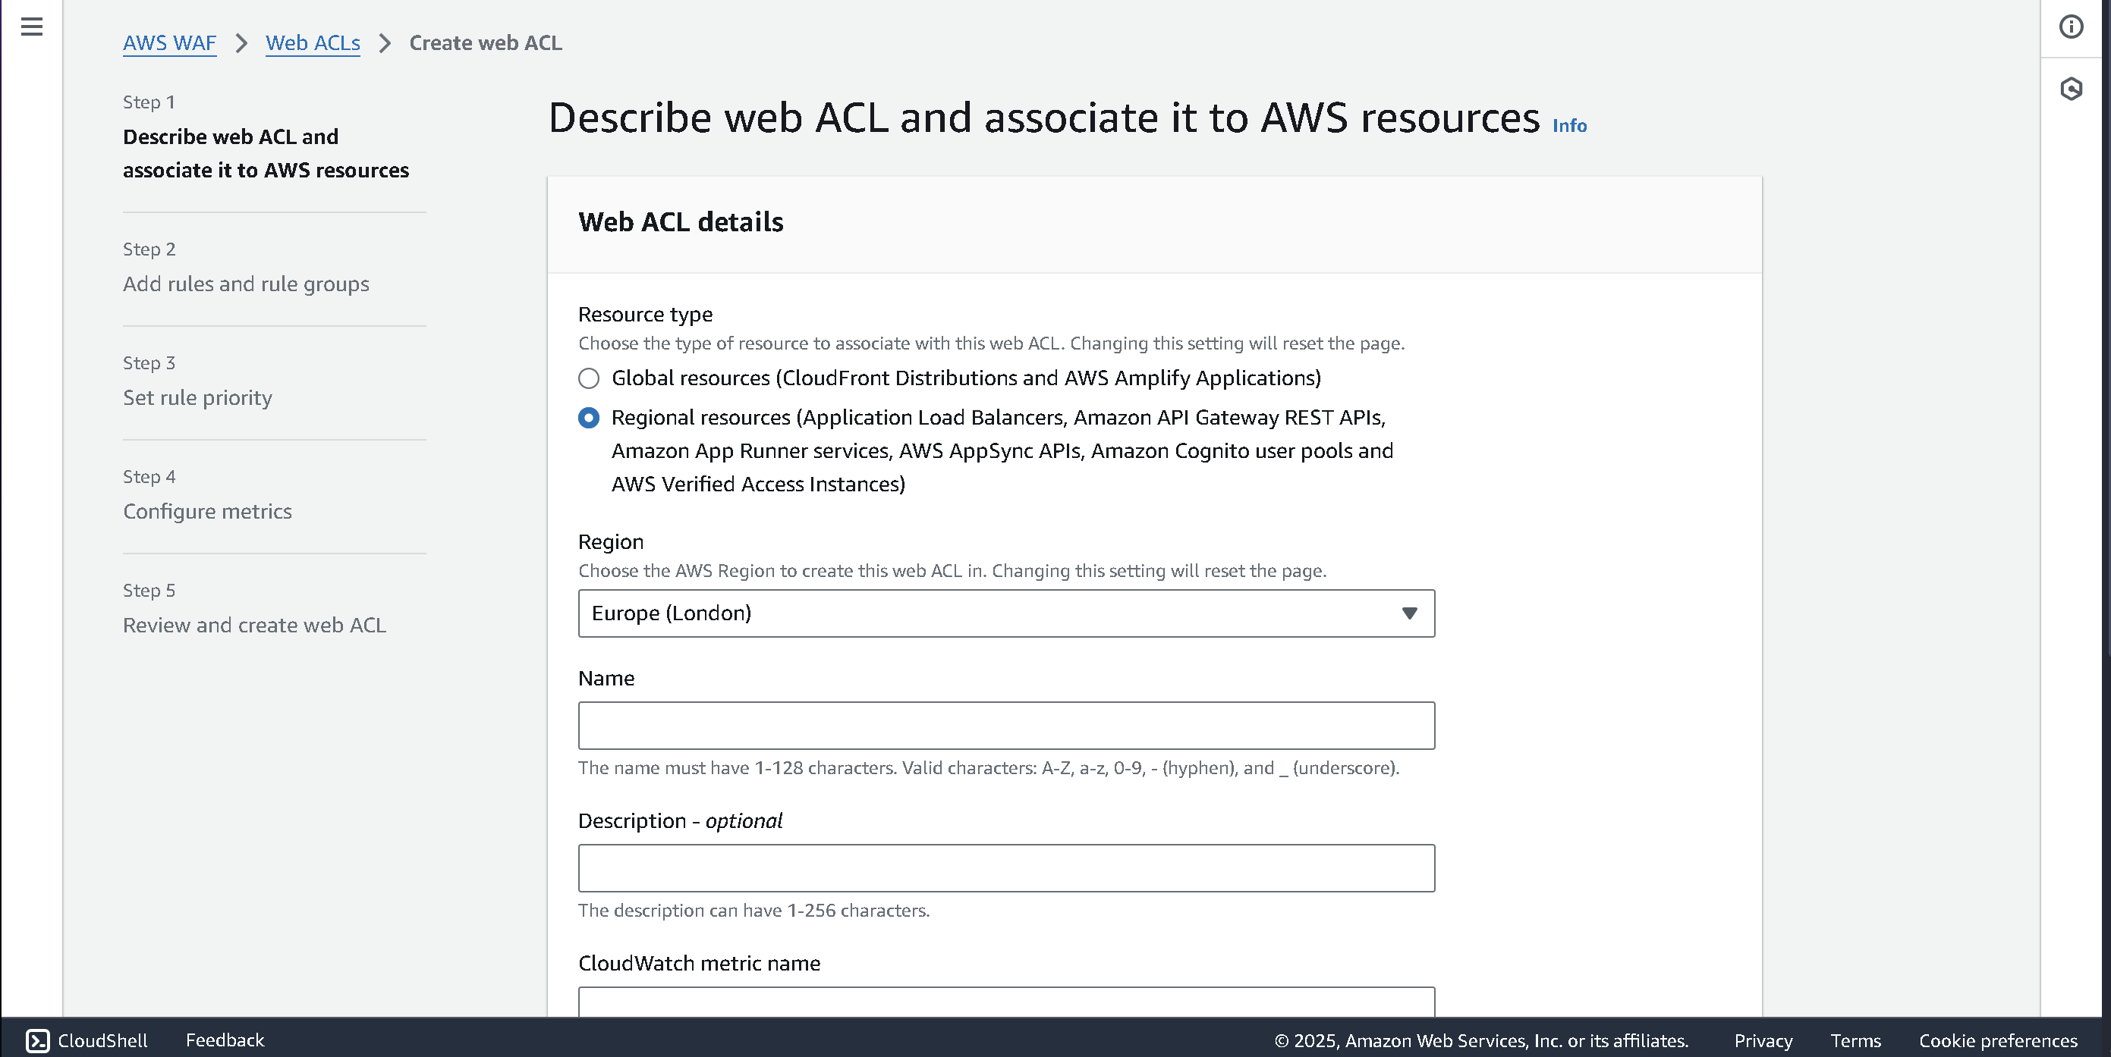Figure 6.7: Creating WAF

Costing

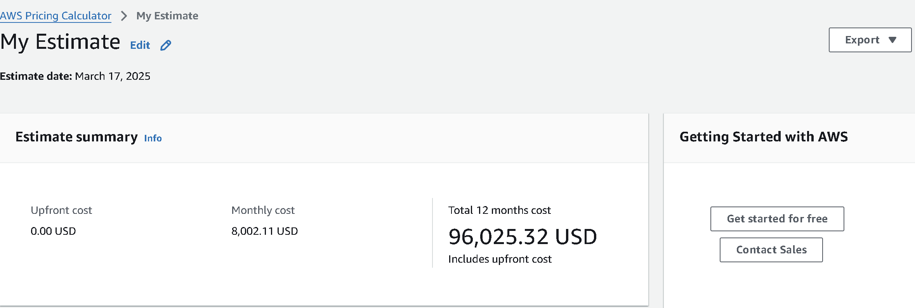
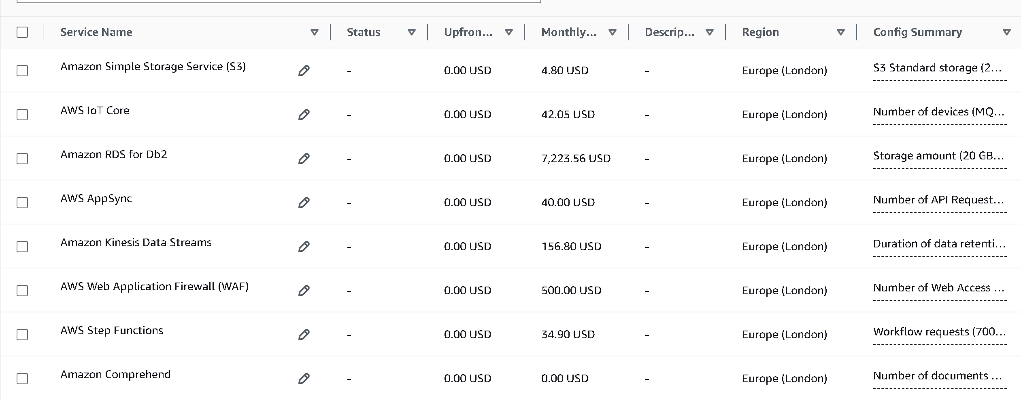Figure 7.1: Total cost

Analysis and Reflection
Sustainment of a smart campus system is a dynamic process that requires effective supervision, flexibility as well as constant evolution. The results also simplify the constant system audits and incorporate an AI-based insight into infrastructure health and readiness into performance reviews. To address the changing needs of education, cloud modelling of the IT environment makes planning and implementation of technologically enhanced classrooms like AR/VR, or innovative learning analysis seamless. Dealing with changes in regulation, such as in data protection or access requirements, is possible only through dynamic policy management and tracking tools. The feedback loops assist in integrating the change in systems to accommodate the stakeholders and the reality of academics. Furthermore, it is agreeable that partnerships with cloud providers enable timely implementation of the required security patch and compliance certifications. Instead, futureproofing was about tackling not only the platform as an IT solution but also the community which the institution had to actively and continually prepare for the change in technology and regulatory environments in lockstep with one another.
The prototype has proved useful and logical as a cloud-based smart campus system. It manages to incorporate AWS services into unified storage and processing of data, application of real-time decision-making processes, and availability of educational content. They provide IoT integration functionality, data analysis, and deep automation integration to suggest that it is aligned with the initial goals set out in this evolving field. However, the differences in the implementation in the real world might be seen pertaining to scalability and users, particularly non-IT employees. Although the requirements that are met include the ability to centralize management and offer predictive analytics, further enhancement will need to be pursued, specifically regarding the application’s ease of use and with regard to meeting the legal standards. In general, it is possible to state that the given prototype provides a good foundation for a modern, innovative campus infrastructure for the future.

References
Armenatzoglou, N., Basu, S., Bhanoori, N., Cai, M., Chainani, N., Chinta, K., Govindaraju, V., Green, T.J., Gupta, M., Hillig, S., Hotinger, E., Leshinsky, Y., Liang, J., McCreedy, M., Nagel, F., Pandis, I., Parchas, P., Pathak, R., Polychroniou, O. and Rahman, F. (2022) Amazon Redshift re-invented. Proceedings of the 2022 International Conference on Management of Data, pp. 2205–2217. Available at: https://doi.org/10.1145/3514221.3526045
Wang, W., Sadjadi, S.M. and Rishe, N. (2024) A survey of major cybersecurity compliance frameworks. IEEE 10th Conference on Big Data Security on Cloud (BigDataSecurity), pp. 1–29. Available at: https://doi.org/10.1109/bigdatasecurity62737.2024.00013

